**Steps to Access YouTube Data API v3 Key Service from Google Console**

* Once you Click on the link from application: (See below screen shot circled)

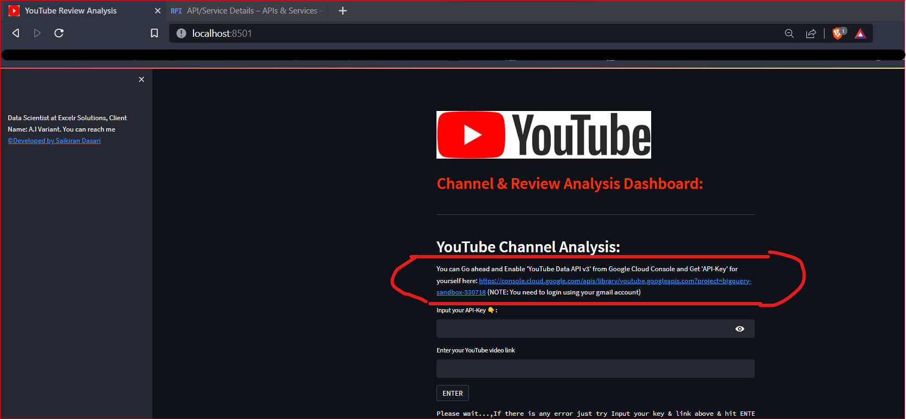

* Enable it!

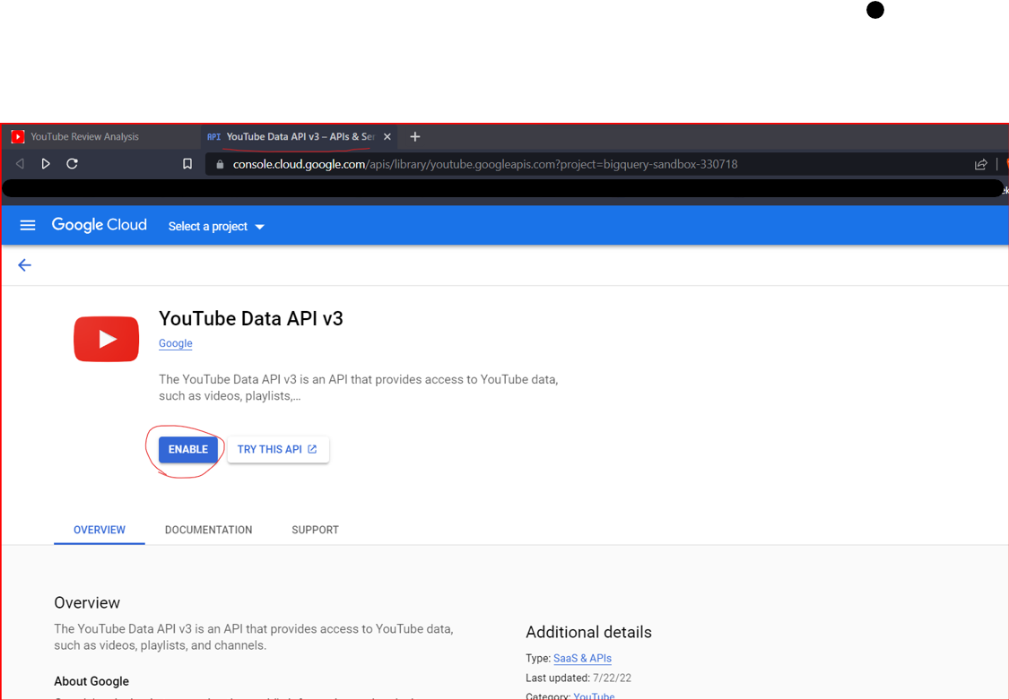

* Manage it from your Newly Create Project

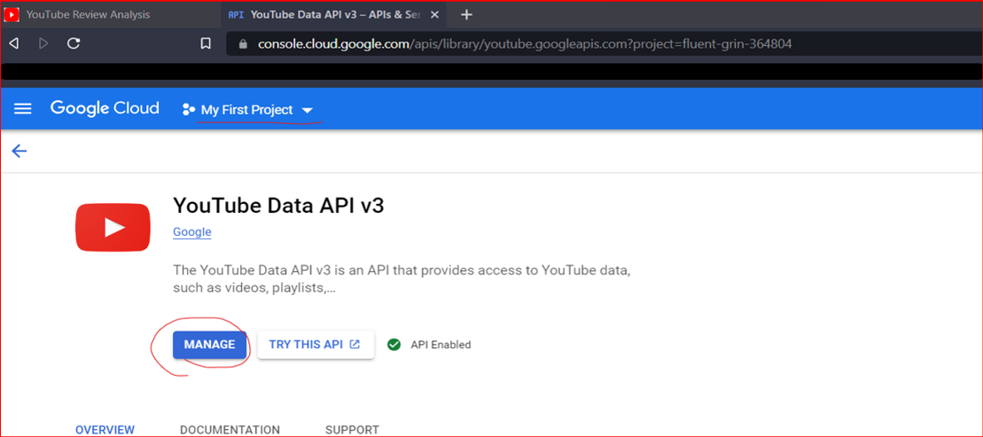

Scroll Down and Under ‘Credentials’ tab: you can see your API-Key and click on **Show Key**

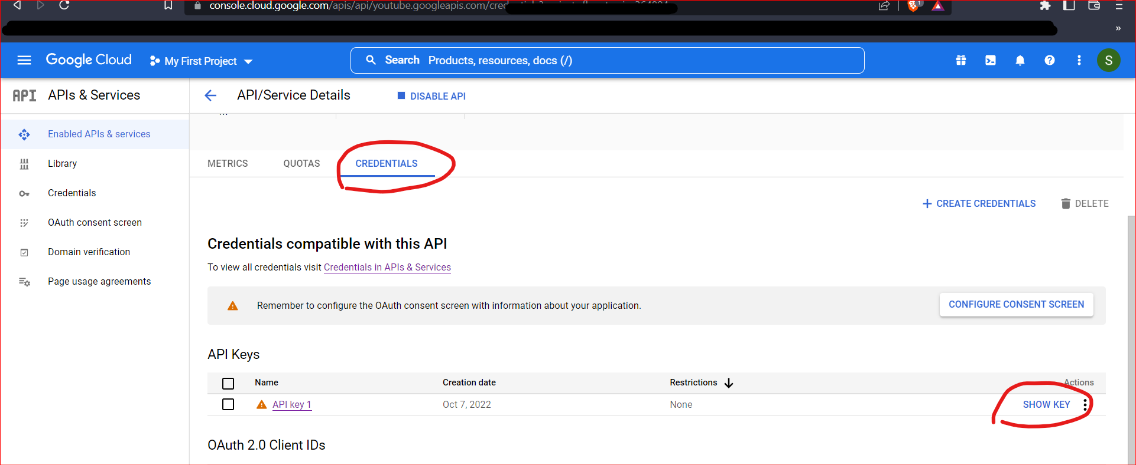

**Copy by Clicking the icon**

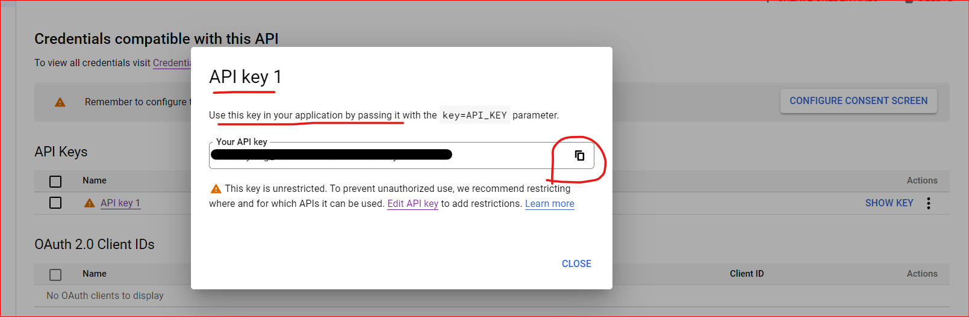

**DONE!! and just paste that in the application and enter**